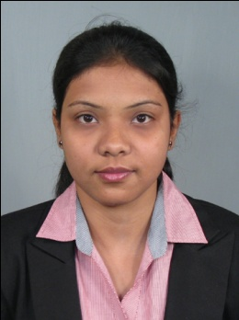 **Curriculum Vitae**

# Name : Silpi Mitra

# Permanent Address : Shyama Apartment, Block-2, Flat no.-1c,

# Near old dgms coloney,Dhanbad

State- Jharkhand, Pin No.- 826001.

**Mobile No. :** 8697881516/ 9431799697

**Date of birth :** 15.05.1990

# E-mail id. : [silpimitra5@gmail.com](mailto:silpimitra5@gmail.com)

**ACADEMIC QUALIFICATION**

|  |  |  |  |  |
| --- | --- | --- | --- | --- |
| Year | Examination | Institute | Board/University | Div/CGPA |
| 2014 | MBA(Marketing) | Heritage Institute of Technology | West Bengal University of Technology | 7.94 |
| 2012 | BBA(H) | NSHM Knowledge Campus,Durgapur | West Bengal University of Technology | 7.14 |
| 2009 | Higher Secondary | Dhanbad Public School | CBSE | 81 |
| 2007 | Secondary | DeNobiliSchool,Sijua | ICSE | 59 |

**SUMMER INTERNSHIP**

**Bhaskar Denim June 2013 to August 2013**

**Project Title:** Sectoral study on manufacturers and consumers in the

apparel sector with reference to Kolkata market

**Method :**Survey was done through questionnaires and interview of the

manufacturers and consumers of Readymade garments.

**TRAINING DONE**

|  |  |  |
| --- | --- | --- |
| Name of the Organisation | Project Title | Duration |
| MSME | Business Skill Development Program | 45Days |
| Coal India Limited(BCCL) | Consumer Buying Motives | 20Days |

**KEY PROJECT**

Consumer Buying Motives- The project was conducted in Coal India(BCCL)

to understand and analyze the motive of a

consumer when he/she is buying the goods.

Unorganized Business Sector- Survey was conducted to know and learn about

private coaching centres in and around Kolkata,

their mode of operations, their earnings and how

the government is losing tax benefit.

**SPECIALIZATION**

Marketing(major), Human resource(minor)

**WORK EXPERIENCE**

* Worked as Field Executive in Indian Grameen Services (IGS) for FPO promotion in association with RKVY Government of India.
* Worked as Chief Executive Officer with the Jhalda Krishi Vikash Agro Producer Co. Ltd. (FPO) which is promoted by IGS in association with RKVY Government of India.
* Presently working with Youth 4 Jobs as Project Executive under Tech Mahindra Foundation Skill Development Project

**LANGUAGES KNOWN**

English, Hindi,Bengali

**COMPUTER KNOWLEDGE**

MS Office

**ACHIEVEMENTS**

Obtained 3rd position in higher secondary board examination

Got 3rd prize in school in flower arrangement competition

**EXTRA CURRICULAR ACTIVITIES**

Indulge in gardening

Interacting with people through social networking sites